1. **Agenda**:
   1. In this section, we will have a brief look at the Set and List Data Structure.
2.   
   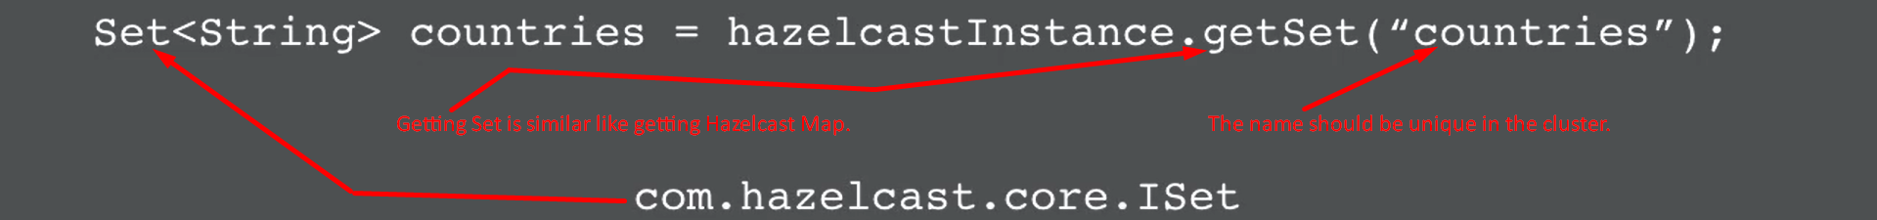
3. Text

   Description automatically generated
4. However, keep in mind that this is Distributed Set and putting the value into this Set and retrieving them will be done remotely.  
   So, you need to make sure you program with performance in mind like using addAll() instead of multiple calls to add().
5. A couple of things about **com.hazelcast.core.ISet** Data Structure.
   1. It’s non-partition Data Structure.  
      All of the data from this Data Structure will be stored on a Single Storage Node (Cluster Member = HazelcastInstance).

And the backup copies on different Storage Node.  
Therefore, its side is restricted with the size of Storage Node’s memory.  
Therefore, it is best not to use large amount of data within a single name set.  
Therefore, create a set with different name where possible to better distribute the data.

* 1. When using the iterator on the ISet, there is no batching.  
     Therefore, if you do **myISet.iterator()**.next(), the entire ISet will be serialized to the local machine.   
     Therefore, this can be really inefficient, so use it with care.  
     Text

     Description automatically generated

1. **List Data Structure**:
   1. Very Similar to List Data Structure.
   2.   
      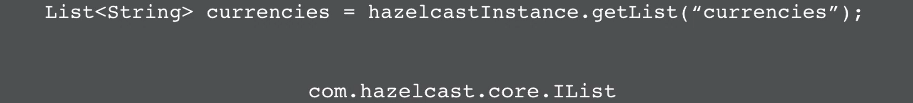
   3. Text

      Description automatically generated